APPLICATION TO DESIGNATE A NEIGHBOURHOOD PLAN AREA

Marldon Parish Council has applied to South Hams District Council to write a neighbourhood plan for their area. This plan will consider how and where future development could take place in Marldon Parish. We are asking for your thoughts on whether the proposed plan area is appropriate. If the area is approved, there will be an opportunity for you to get involved in what you would like to see in the plan.

The deadline for receiving comments on the proposed plan area is Monday 13th June 2016. Any comments should be sent to: Neighbourhood Planning, South Hams District Council, Follaton House, Plymouth Road, Totnes, TQ9 5NE, or email: neighbourhood.planning@swdevon.gov.uk

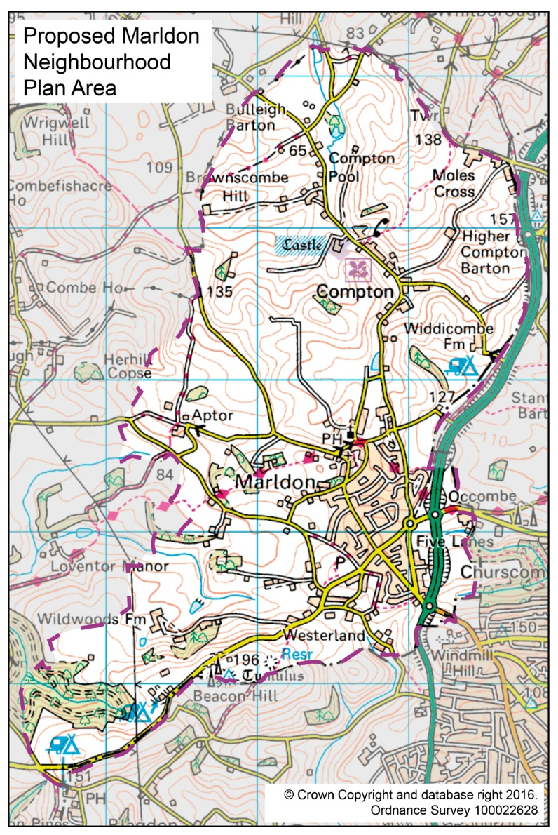
To view the plan area application please visit www.southhams.gov.uk/shneighbourhoodplans or contact the Council’s Neighbourhood Planning Team for more information. Only comments relating to the designation of the plan area can be considered at this time. The proposed neighbourhood plan area follows the existing Parish boundary:

Please note: Any comments made about the proposed plan area cannot be treated as confidential and may be made publicly available at the Council’s offices and on the website. Your personal information will be held securely by South Hams District Council for the above purpose, in accordance with the Data Protection Act 1998.

